**PRACTICAL 4.1**

# PRACTICAL-4

**Aim:** Create simple application which shows use of seek bar.

## Design:

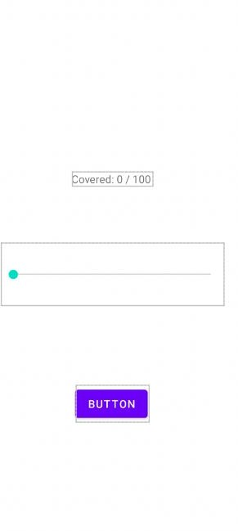

**Input (Java Code):**

package com.example.practical_4_1;

import androidx.appcompat.app.AppCompatActivity; import androidx.constraintlayout.widget.ConstraintLayout; import android.os.Bundle;

import android.widget.Button; import android.widget.SeekBar; import android.widget.TextView; import android.widget.Toast;

public class MainActivity extends AppCompatActivity { SeekBar sb;

TextView tv; Button btn; ConstraintLayout c; @Override

protected void onCreate(Bundle savedInstanceState) {

super.onCreate(savedInstanceState); setContentView(R.layout.activity_main); sb =findViewById(R.id.seekBar);

tv = findViewById(R.id.textView); btn = findViewById(R.id.button3); c = findViewById(R.id.cons);

sb.setOnSeekBarChangeListener(new SeekBar.OnSeekBarChangeListener() { @Override

public void onProgressChanged(SeekBar seekBar, int i, boolean b) { tv.setText("Covered: "+ Integer.toString(i) + "/ 100"); Toast.makeText(MainActivity.this, Integer.toString(i),

Toast.LENGTH_SHORT).show(); if(i == 50){

c.setBackgroundColor(getResources().getColor(R.color.teal_200));

}

}

@Override

public void onStartTrackingTouch(SeekBar seekBar) {

}

@Override

public void onStopTrackingTouch(SeekBar seekBar) {

}

});

}

}

## Output:

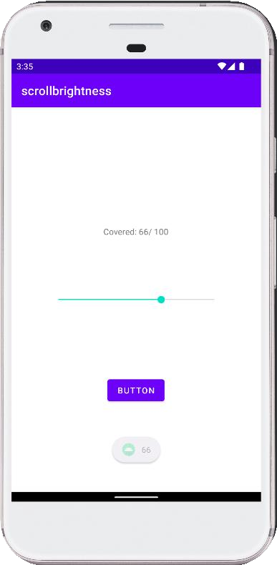

**Conclusion:** In this practical, we learned about seek bar that is scroll brightness and show how much of seek bar is covered using Toast widget.

## PRACTICAL 4.2

**Aim:** Create a simple application that demonstrate a use of Rating Bar.

## Design:

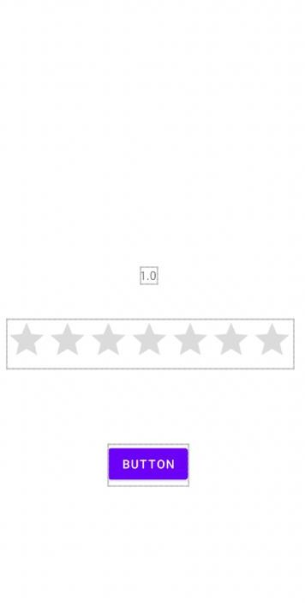

**Input (Java Code):**

package com.example.practical_4_2;

import androidx.appcompat.app.AppCompatActivity; import android.os.Bundle;

import android.view.View; import android.widget.Button; import android.widget.RatingBar; import android.widget.TextView;

import android.widget.Toast;

public class MainActivity extends AppCompatActivity { TextView tv;

Button btn1;

RatingBar rb;

@Override

protected void onCreate(Bundle savedInstanceState) { super.onCreate(savedInstanceState); setContentView(R.layout.activity_main); tv=findViewById(R.id.textView); btn1=findViewById(R.id.button);

rb= findViewById(R.id.ratingBar);

rb.setOnRatingBarChangeListener(new RatingBar.OnRatingBarChangeListener() {

@Override

public void onRatingChanged(RatingBar ratingBar, float v, boolean b) { tv.setText(Float.toString(v));

}

});

btn1.setOnClickListener(new View.OnClickListener() {

@Override

public void onClick(View view) { Toast.makeText(MainActivity.this, Float.toString(rb.getRating()),

Toast.LENGTH_SHORT).show();

}

});

}

}

## Output:

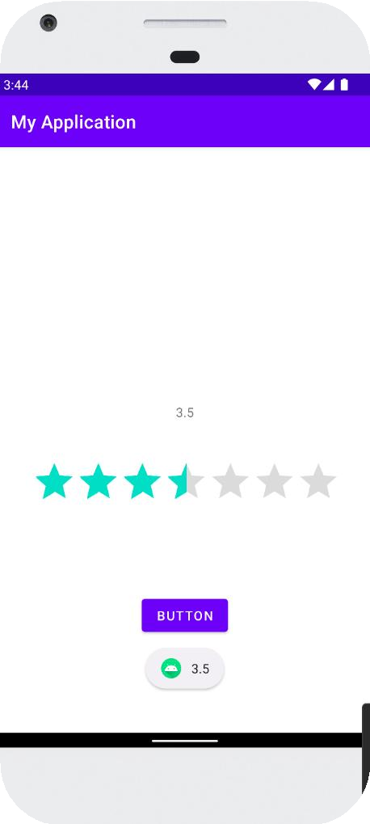

**Conclusion:** In this practical, we learned about Rating Widget and how to display rating to current app.

## PRACTICAL 4.3

**Aim:** Create a simple application that show the use of Alert Dialog box.

## Design:



**Input (Java Code):**

package com.example.practical_4_3;

import androidx.appcompat.app.AlertDialog;

import androidx.appcompat.app.AppCompatActivity; import android.content.DialogInterface;

import android.os.Bundle; import android.view.View; import android.widget.Button;

import android.widget.Toast;

public class MainActivity extends AppCompatActivity {

Button btn1;

@Override

protected void onCreate(Bundle savedInstanceState) { super.onCreate(savedInstanceState); setContentView(R.layout.activity_main);

btn1 =findViewById(R.id.button); btn1.setOnClickListener(new View.OnClickListener() {

@Override

public void onClick(View view) {

AlertDialog.Builder builder = new AlertDialog.Builder(MainActivity.this); builder.setTitle("Quit"); builder.setIcon(R.drawable.ic_baseline_close_24); builder.setMessage("Do you want to Exit Application? "); builder.setPositiveButton("yes", new DialogInterface.OnClickListener() {

@Override

public void onClick(DialogInterface dialogInterface, int i) { finish();

}

});

builder.setNegativeButton ("no", new DialogInterface.OnClickListener() {

@Override

public void onClick(DialogInterface dialogInterface, int i) { dialogInterface.cancel();

}

});

builder.show();

btn1.setOnLongClickListener(new View.OnLongClickListener() {

@Override

public boolean onLongClick(View view) { Toast.makeText(MainActivity.this, "Don’t touch",

Toast.LENGTH_SHORT).show(); return true;

}

});

}

});

}

}

## Output:

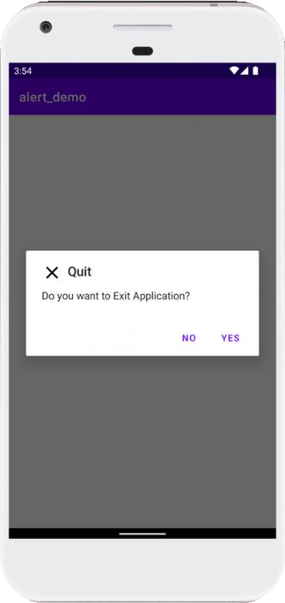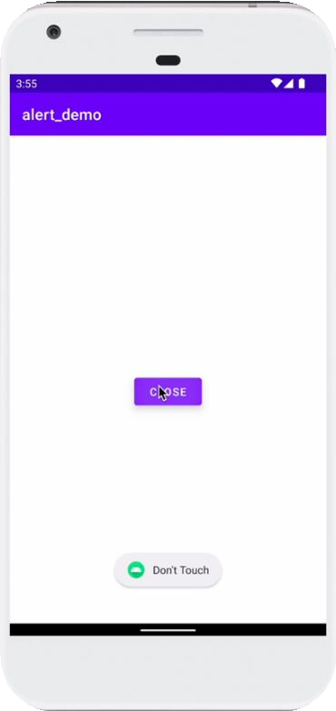

**Conclusion:** In this practical, we learned about On Long press property of a button and also made basic Alert dialog Box in android